**Database Artifacts**

Byeongyun Goo (#040888224), Zeyang Hu (#040885680), Sohaila Binte Ridwan (#040847430)

**ER Diagram**

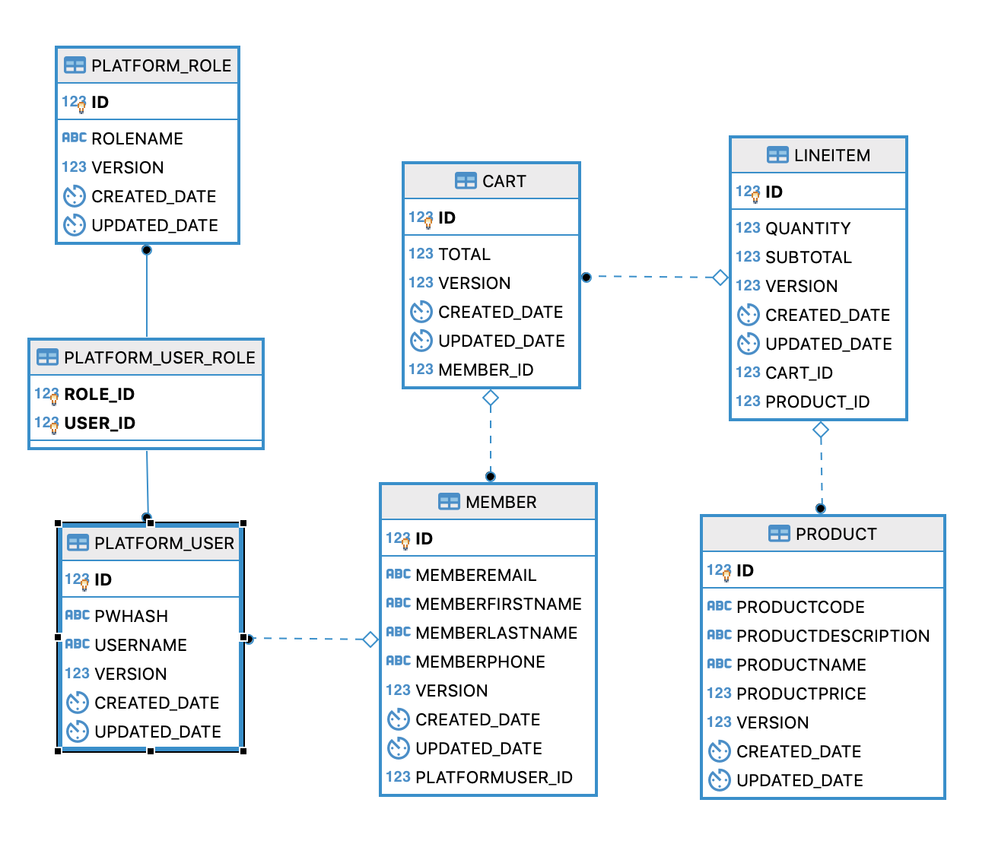

**SQL DDL**

**CART**

-- Drop table

-- DROP TABLE PUBLIC.CART

**CREATE** **TABLE** PUBLIC.CART (

ID **INTEGER** **DEFAULT** (**NEXT** VALUE **FOR** PUBLIC.SYSTEM_SEQUENCE_C6EF36C9_3734_472B_9645_B074A07DBEB9) **NOT** **NULL** AUTO_INCREMENT,

TOTAL **DOUBLE**,

VERSION **INTEGER**,

CREATED_DATE **TIMESTAMP**,

UPDATED_DATE **TIMESTAMP**,

MEMBER_ID **INTEGER**,

**CONSTRAINT** CONSTRAINT_1 **PRIMARY** **KEY** (ID),

**CONSTRAINT** FK_CART_MEMBER_ID **FOREIGN** **KEY** (MEMBER_ID) **REFERENCES** PUBLIC."MEMBER"(ID) **ON** **DELETE** **RESTRICT** **ON** **UPDATE** **RESTRICT**

);

**CREATE** **INDEX** FK_CART_MEMBER_ID_INDEX_1 **ON** PUBLIC.CART (MEMBER_ID);

**CREATE** **UNIQUE** **INDEX** PRIMARY_KEY_1 **ON** PUBLIC.CART (ID);

**LINEITEM**

-- Drop table

-- DROP TABLE PUBLIC.LINEITEM

**CREATE** **TABLE** PUBLIC.LINEITEM (

ID **INTEGER** **DEFAULT** (**NEXT** VALUE **FOR** PUBLIC.SYSTEM_SEQUENCE_6488A14D_B368_4510_9CF9_CDED6919D529) **NOT** **NULL** AUTO_INCREMENT,

QUANTITY **INTEGER**,

SUBTOTAL **DOUBLE**,

VERSION **INTEGER**,

CREATED_DATE **TIMESTAMP**,

UPDATED_DATE **TIMESTAMP**,

CART_ID **INTEGER**,

PRODUCT_ID **INTEGER**,

**CONSTRAINT** CONSTRAINT_75 **PRIMARY** **KEY** (ID),

**CONSTRAINT** FK_LINEITEM_CART_ID **FOREIGN** **KEY** (CART_ID) **REFERENCES** PUBLIC.CART(ID) **ON** **DELETE** **RESTRICT** **ON** **UPDATE** **RESTRICT**,

**CONSTRAINT** FK_LINEITEM_PRODUCT_ID **FOREIGN** **KEY** (PRODUCT_ID) **REFERENCES** PUBLIC.PRODUCT(ID) **ON** **DELETE** **RESTRICT** **ON** **UPDATE** **RESTRICT**

);

**CREATE** **INDEX** FK_LINEITEM_CART_ID_INDEX_7 **ON** PUBLIC.LINEITEM (CART_ID);

**CREATE** **INDEX** FK_LINEITEM_PRODUCT_ID_INDEX_7 **ON** PUBLIC.LINEITEM (PRODUCT_ID);

**CREATE** **UNIQUE** **INDEX** PRIMARY_KEY_75 **ON** PUBLIC.LINEITEM (ID);

**MEMBER**

-- Drop table

-- DROP TABLE PUBLIC."MEMBER"

**CREATE** **TABLE** PUBLIC."MEMBER" (

ID **INTEGER** **DEFAULT** (**NEXT** VALUE **FOR** PUBLIC.SYSTEM_SEQUENCE_DCDB023C_CF53_42AE_BA2D_49FF9152836F) **NOT** **NULL** AUTO_INCREMENT,

MEMBEREMAIL **VARCHAR**,

MEMBERFIRSTNAME **VARCHAR**,

MEMBERLASTNAME **VARCHAR**,

MEMBERPHONE **VARCHAR**,

VERSION **INTEGER**,

CREATED_DATE **TIMESTAMP**,

UPDATED_DATE **TIMESTAMP**,

PLATFORMUSER_ID **INTEGER**,

**CONSTRAINT** CONSTRAINT_8 **PRIMARY** **KEY** (ID),

**CONSTRAINT** FK_MEMBER_PLATFORMUSER_ID **FOREIGN** **KEY** (PLATFORMUSER_ID) **REFERENCES** PUBLIC.PLATFORM_USER(ID) **ON** **DELETE** **RESTRICT** **ON** **UPDATE** **RESTRICT**

);

**CREATE** **INDEX** FK_MEMBER_PLATFORMUSER_ID_INDEX_8 **ON** PUBLIC."MEMBER" (PLATFORMUSER_ID);

**CREATE** **UNIQUE** **INDEX** PRIMARY_KEY_8 **ON** PUBLIC."MEMBER" (ID);

**PLATFORM_ROLE**

-- Drop table

-- DROP TABLE PUBLIC.PLATFORM_ROLE

**CREATE** **TABLE** PUBLIC.PLATFORM_ROLE (

ID **INTEGER** **DEFAULT** (**NEXT** VALUE **FOR** PUBLIC.SYSTEM_SEQUENCE_85BD0055_5C75_4EAA_9732_BA56253E13D5) **NOT** **NULL** AUTO_INCREMENT,

ROLENAME **VARCHAR**,

VERSION **INTEGER**,

CREATED_DATE **TIMESTAMP**,

UPDATED_DATE **TIMESTAMP**,

**CONSTRAINT** CONSTRAINT_D **PRIMARY** **KEY** (ID)

);

**CREATE** **UNIQUE** **INDEX** PRIMARY_KEY_D **ON** PUBLIC.PLATFORM_ROLE (ID);

**PLATFORM_USER**

-- Drop table

-- DROP TABLE PUBLIC.PLATFORM_USER

**CREATE** **TABLE** PUBLIC.PLATFORM_USER (

ID **INTEGER** **DEFAULT** (**NEXT** VALUE **FOR** PUBLIC.SYSTEM_SEQUENCE_A3E08829_9083_44CC_8B37_646D8DF0363A) **NOT** **NULL** AUTO_INCREMENT,

PWHASH **VARCHAR**,

USERNAME **VARCHAR**,

VERSION **INTEGER**,

CREATED_DATE **TIMESTAMP**,

UPDATED_DATE **TIMESTAMP**,

**CONSTRAINT** CONSTRAINT_DB **PRIMARY** **KEY** (ID)

);

**CREATE** **UNIQUE** **INDEX** PRIMARY_KEY_DB **ON** PUBLIC.PLATFORM_USER (ID);

**PLATFORM_USER_ROLE**

-- Drop table

-- DROP TABLE PUBLIC.PLATFORM_USER_ROLE

**CREATE** **TABLE** PUBLIC.PLATFORM_USER_ROLE (

ROLE_ID **INTEGER** **NOT** **NULL**,

USER_ID **INTEGER** **NOT** **NULL**,

**CONSTRAINT** CONSTRAINT_2 **PRIMARY** **KEY** (ROLE_ID,USER_ID),

**CONSTRAINT** FK_PLATFORM_USER_ROLE_ROLE_ID **FOREIGN** **KEY** (ROLE_ID) **REFERENCES** PUBLIC.PLATFORM_ROLE(ID) **ON** **DELETE** **RESTRICT** **ON** **UPDATE** **RESTRICT**,

**CONSTRAINT** FK_PLATFORM_USER_ROLE_USER_ID **FOREIGN** **KEY** (USER_ID) **REFERENCES** PUBLIC.PLATFORM_USER(ID) **ON** **DELETE** **RESTRICT** **ON** **UPDATE** **RESTRICT**

);

**CREATE** **INDEX** FK_PLATFORM_USER_ROLE_ROLE_ID_INDEX_2 **ON** PUBLIC.PLATFORM_USER_ROLE (ROLE_ID);

**CREATE** **INDEX** FK_PLATFORM_USER_ROLE_USER_ID_INDEX_2 **ON** PUBLIC.PLATFORM_USER_ROLE (USER_ID);

**CREATE** **UNIQUE** **INDEX** PRIMARY_KEY_2 **ON** PUBLIC.PLATFORM_USER_ROLE (ROLE_ID,USER_ID);

**PRODUCT**

-- Drop table

-- DROP TABLE PUBLIC.PRODUCT

**CREATE** **TABLE** PUBLIC.PRODUCT (

ID **INTEGER** **DEFAULT** (**NEXT** VALUE **FOR** PUBLIC.SYSTEM_SEQUENCE_BD7C47C8_9912_4CA0_8703_BABFCFE1F9BD) **NOT** **NULL** AUTO_INCREMENT,

PRODUCTCODE **VARCHAR**,

PRODUCTDESCRIPTION **VARCHAR**,

PRODUCTNAME **VARCHAR**,

PRODUCTPRICE **DOUBLE**,

VERSION **INTEGER**,

CREATED_DATE **TIMESTAMP**,

UPDATED_DATE **TIMESTAMP**,

**CONSTRAINT** CONSTRAINT_18 **PRIMARY** **KEY** (ID)

);

**CREATE** **UNIQUE** **INDEX** PRIMARY_KEY_18 **ON** PUBLIC.PRODUCT (ID);